Profile of a wine consumer

A consumer profile is a crucial aspect of a business. It is the description of customers that involves demographic, psychographic, geographic attributes and buying patterns. Wine has existed for centuries as part of a class of beverages consumed by people. To evaluate the profile of a wine consumer, there is a need to concentrate on the demographic, socioeconomic and historical elements of these consumers. The demand for wine consumption has undoubtedly been influenced by culture, social and religious attributes that surround consumers.
Wine consumption is limited to a certain age in different countries. For example, in the United States, the minimum age for consumption of wine became 21 in the mid-eighties. From this, it is clear that age is a cardinal demographic aspect that limits certain consumers to wine consumption. According to the “Who’s Buying Wine Series” (2011), it is described that wine was consumed at home by a consumer group aged 45-74 in 2010. These were people married but without children and even graduates from college. From these statistics was also stated that customers who consumed wine at restaurants and bars were a group aged 35-64(Villanueva, Castillo-Valero& Garcia-Cortijo ,2015). This clearly shows that people who consume wine are mostly adults.
In relation to consumer loyalty to a certain wine brand, some don’t put importance on this, but some customers are used to the consumption of a specific brand. This means that loyalty on a specific brand depends on customer preference. There is a significant difference between older and younger wine consumers. The older wine consumers are more frequent than the younger ones. The later consumes wine less frequent.

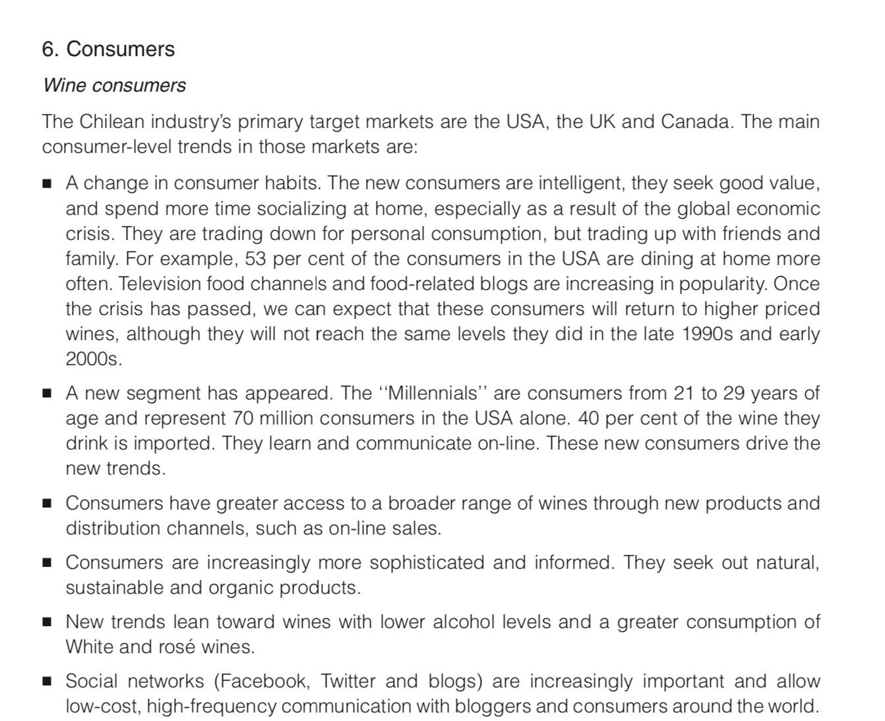
REPHRASE OR EXTRACT MOST IMPORTANT PARTS, CAN DELETE THIS PHOTO AFTERWARD.

Image of wine from Chile

The Chile wine sector has embraced local production accompanied by exportation since the 1990s. Firms in Chile produce wine locally and exports it in primarily bottled and boxed wine. There is a range of wines that are exported. This includes market segments such as super-premium, premium, varietal and ultra-premium. This focuses on grape varieties such as Cabernet Sauvignon, Merlot, Carmenere, Sauvignon Blanc, and Chardonnay. The winery in Chile has its own local grape production and winemaking processes (Fernandez-Stark & Bamber,2016).
Chile wine is stationed in the international market in that the country is the eighth largest wine producer and the fifth largest exporter. For this reason, it reached a market share of 8% in the global wine market. The country exports 70% of its wine production. It is the most globalized wine industry. Chile wine has 150 countries where it is sold and up to 1.5 billion annual consumers. Thus, wine is the best-known global ambassador for Chile (Felzensztein,2014)

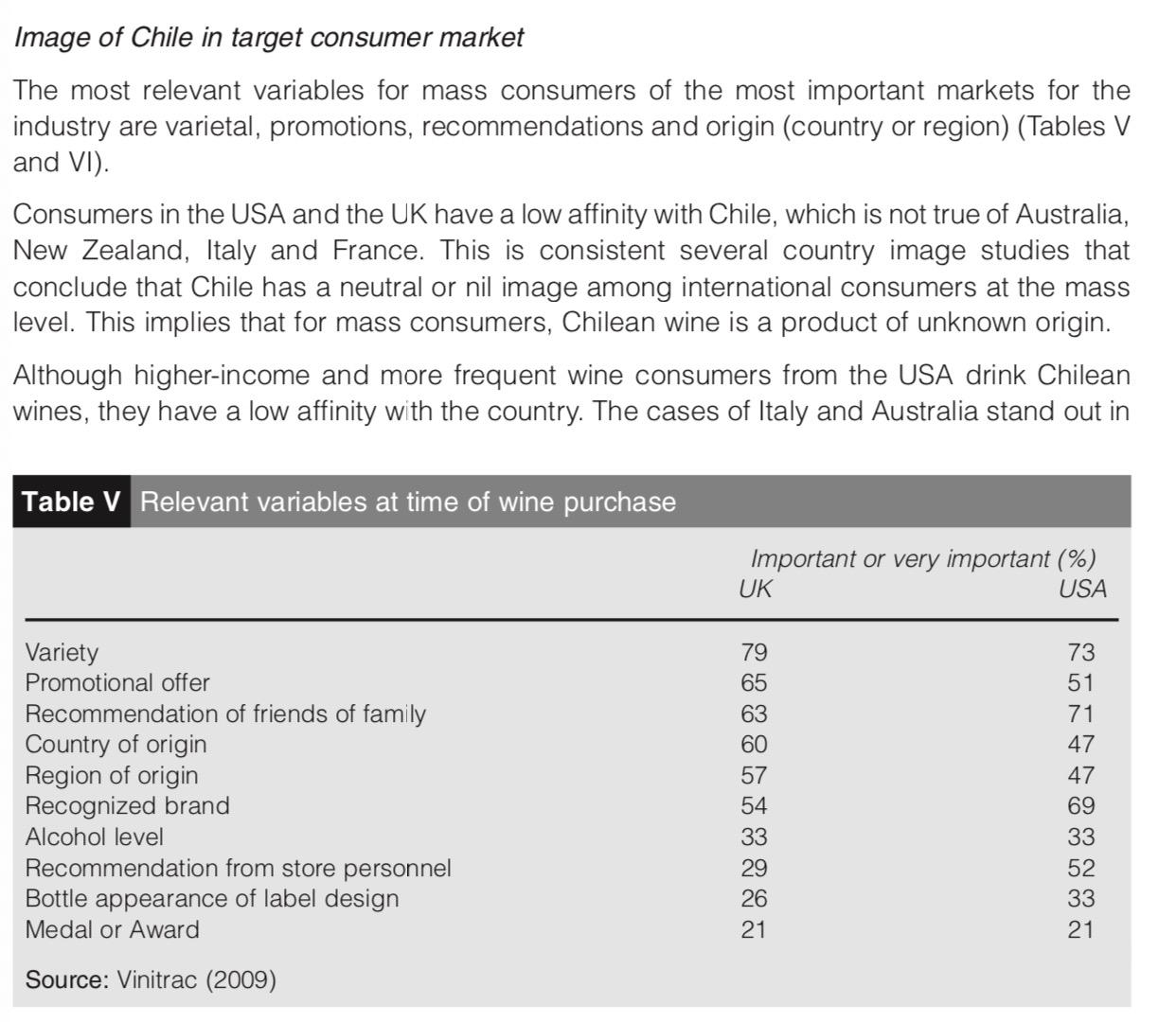
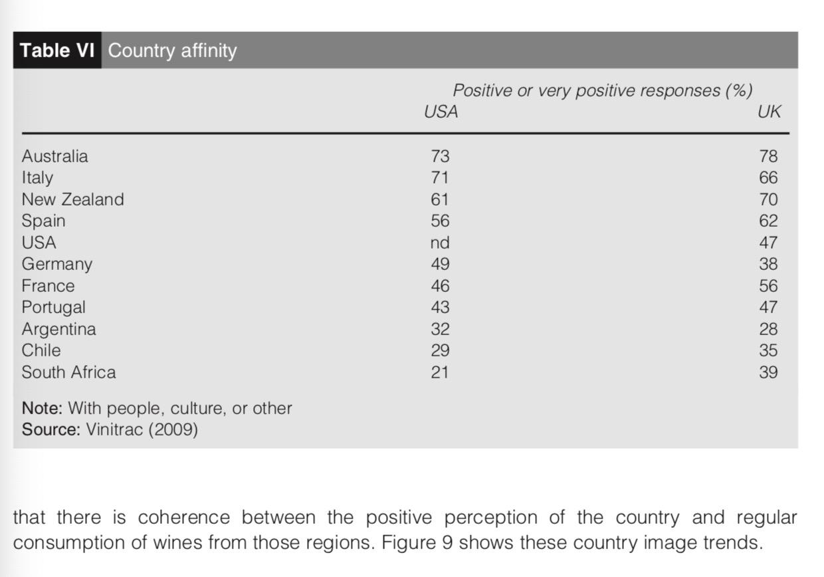
REPHRASE OR EXTRACT MOST IMPORTANT PARTS, CAN DELETE THESE PHOTOS AFTERWARD.

References
Felzensztein, C. (2014). The Chilean wine industry: New international strategies for 2020. Emerald Emerging Markets Case Studies.
Fernandez-Stark, K., & Bamber, P. (2016). Wine industry in Chile. Services in Global Value Chains: Manufacturing-Related Services, 559-592.
Villanueva, E. C., Castillo-Valero, J. S., & García-Cortijo, M. (2015). Who is drinking wine in the United States? The demographic and socio-economic profile of US wine consumers (1972-2012). International Food and Agribusiness Management Review, 18(1030-2016-83073), 39-60.

